Before Submitting a Technical Summary

- A technical summary should be three pages or less (including pictures) with a font size of 11 pt or 12 pt.
- All technical summaries should be submitted to your project manager with the accompanying final report (Reminder: all final reports must be submitted in LTRC’s new accessible template.)
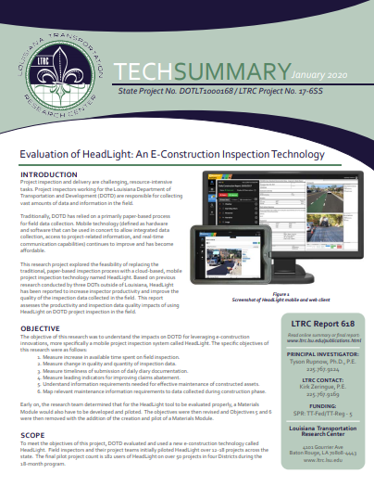
- Each summary should include all the information listed on the next page before submission.
- Please provide captions for all figures, images, and tables.
- There is no specific format, style, or accessibility requirements needed for a technical summary. (Once submitted, the LTRC publications team edits, converts the Word document into a design layout (see image), and sends it for approval with the edited and revised final report.)
- If you have any questions, please contact LTRC’s editor:
Jenny Gilbert at jenny.gilbert@la.gov or 225-767-9150.

To delete this page and begin your technical summary:
- Select the “View” window
- Check “Navigation Pane”
- Right click on “Before Submitting a Technical Summary”
- Delete

LTRC Technical Summary Template
Title:
SIO Number and LTRC Project Number:
Principal Investigator:
Phone Number:
LTRC Contact
Phone Number:
Funding Source:
Keywords:

Introduction
Insert text.

OBJECTIVE
Insert text.

SCOPE
Insert text.

METHODOLOGY
Insert text.

CONCLUSIONS
Insert text.

RECOMMENDATIONS
Insert text.

